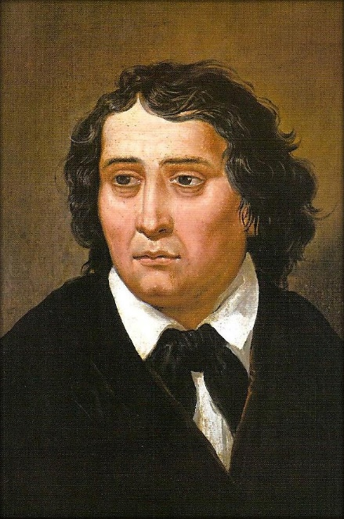
FRANCE PREŠEREN

"Slep je, kdor se s petjam vkvarja,
Kranjec moj mu osle kaže;
pevcu vedno sreča laže,
on živi, umrje brez dnarja."

‘’Blind is he, who sings to us,
the Carniolan men whisper behind his back;
luck always tells lies to a poet,
he lives, dies without money’’
-Glosa, France Prešeren

With these words, one of the Slovenian’s best romantic poets France Prešeren, tells us about the journey of his life- the constant hardships of being a poet during the Romantic period in Slovenia.
He was born on December 3rd, 1800 in Vrba, to a framing family, and died on February 8th, 1849 in Ljubljana. Every year the anniversary of his death is celebrated as Prešernov dan- to honour him, for writing for our people. But it was a hard job being a poet, especially in Slovenia due to the censorship; the Austrian Empire forbade every poem, song or text that could stir an uproar among the minorities.
But that didn’t stop him. He wrote poems and he wrote stories in verses and sonnets; he was truly a genius when it came to poetry. One of his most well-known story in verses is ‘’Krst pri Savici’’, which not only takes elements from both romanticism and realism, but also gives us many messages, hidden behind layers of comparisons and tragic tale-telling. But the work that is considered as his best poetic masterpiece is ‘’Sonetni venec’’- 14 sonnets all connected to each other like a garland which finishes with an ending sonnet, Magistrale. The first letters in the finishing sonnet make out a name: Primicovi Julji, the girl who was his poetic ideal, his muse. His unrequited love for her was never forgotten but rather transformed into his lifestyle. He wrote poems for her, encouraged her to accept his love and in doing so, help the Slovenian minority make their way to freedom from the Austrian regime.
But as his love was never answered, he drank himself to sleep every night. Eventually he did have children with another woman- Ana Jelovšek, to whom he dedicated the poem ‘’Nezakonska mati’’- but he never truly found the same love as he did with Julija .
And so to this day we can admire the masterpieces of France Prešeren in his book ‘’Poezije’’, where his poems will never be forgotten.

